Brian Bauman

CSC 471

**Final Project Proposal**

*Project title:*

Dreamcatcher (individual project)

*Project description:*

This app enables easy access to recording and reviewing dreams you’ve had, replacing the need for a dream journal or diary.

The app replaces your alarm clock, allowing you to configure a time in the morning to wake up. Upon waking up, the app allows you to silence the alarm temporarily, prompting for a description of the dream you had last night. This description can be either spoken or typed, depending on the user preference. The entered description can be categorized as “Dream” or “Nightmare” by default, with the ability to enter custom tags as well.

The description will be saved with the date of the dream as its title by default, but the user can choose to edit this title before the dream is saved. Once saved, the user has the option to review and edit the dreams (including changes to the description, title, tags, etc.).

If the description is not entered after a certain amount of time (specified by the user), the alarm will go off again and the process will repeat.

*Preliminary screen design:*

There are four screens in this app (pictures below):

(1) The alarm screen. This screen creates a sound at the specified time and prompts the user will a “Stop” and “Snooze” button. Pressing “snooze” delays the alarm by 10 minutes. Pressing “Stop” takes you to the dream entry screen.

(2) The dream entry screen. This screen allows the user to enter the details of their dream. It provides a text entry box for typing the dream with the option to transcribe speech to text. It also allows the user the ability to retitle and categorize their dream. It offers the user a “Save” button at the bottom that saves the entered details of the dream. After 2 minutes expire, the screen reverts to the alarm screen.

(3) The dream review screen. This screen lists all previous dreams saved, sorted by date. There is also an option to filter by category (Dream/Nightmare) and by custom tag. This screen is reached from the home screen.

(4) The home screen. This screen is the default screen when opening the app manually. It provides the ability to reach the dream review screen and update settings (adding and removing tags, changing the alarm time, enabling disabling alarms, changing snooze length, and changing the amount of time allocated for entering a dream before the alarm reactivates).

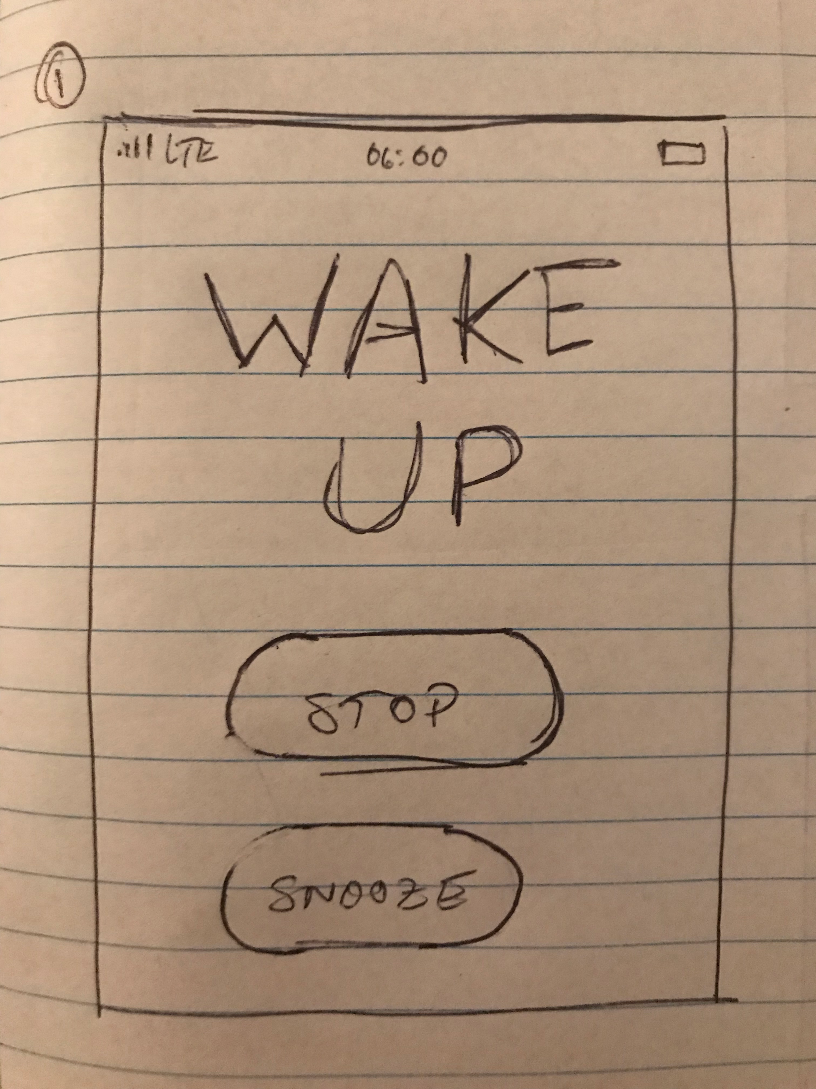 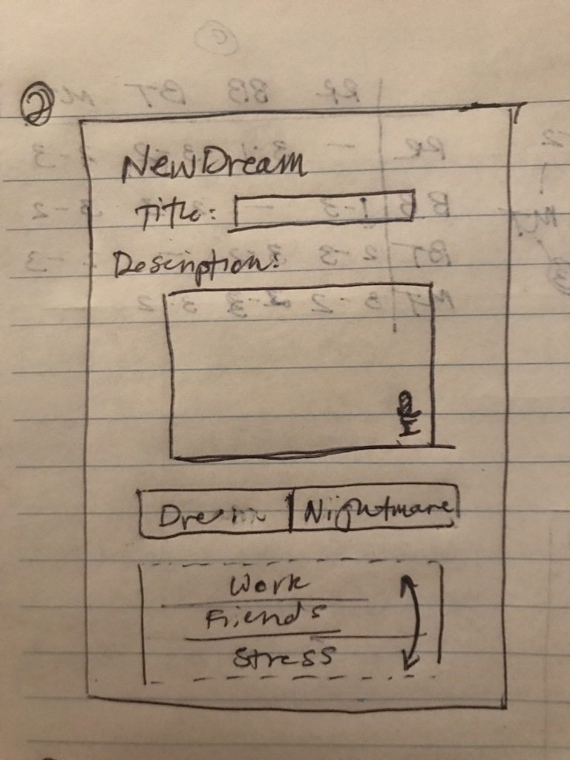

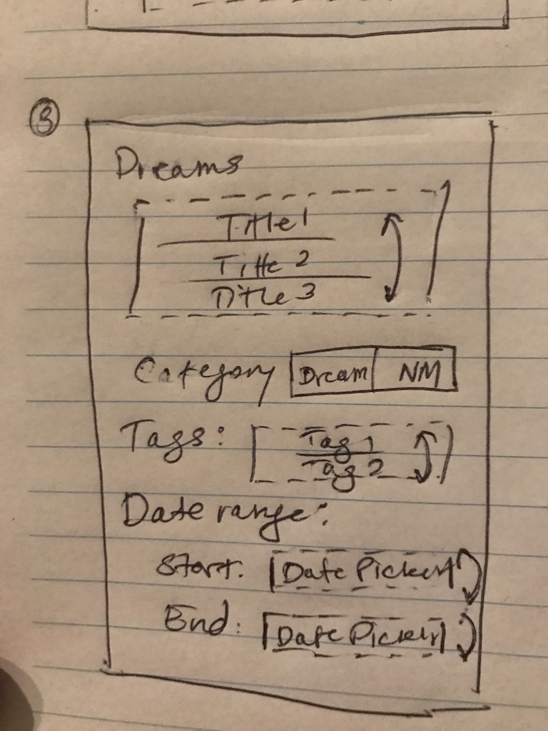 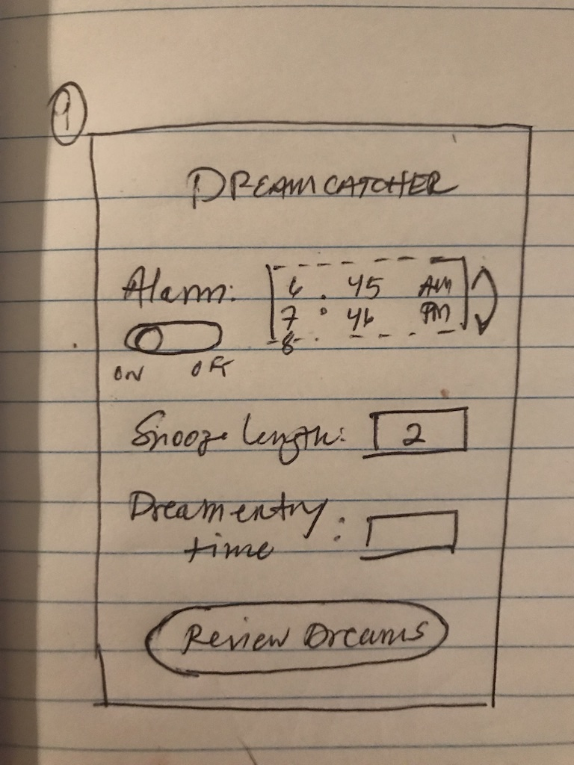

*API features used:*

1. Voice-to-text (recording dreams)
2. Flashing screen 2D-animation (alarm)
3. Text input
4. Pickers (selecting tags, categories, times)